Vietnam 25 Years
From Darkness into Light

Photographs by Catherine Karnow
Exhibition dates: March 6 - 31, 2015

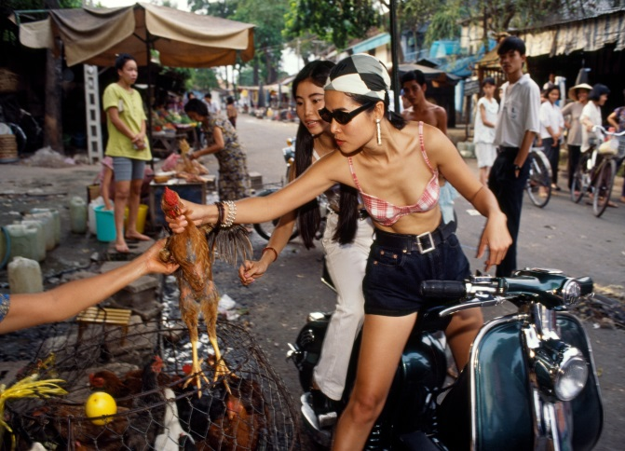

11” x 14” (unframed, matted) HK$2,000
Available for sale at the Admin Office now!
Please enquire with the Administration Officer, Joanne Chung on tel 2521 1511 or email secretary@fcchk.org.

For other sizes and direct sales, please contact Catherine Karnow catherinekarnow@yahoo.com.

